2780 28th Avenue
Greeley, CO 80634
970.339.0011

Patient Information and Billing Authorization
SECTION ONE
Patient First Name: _________________________ Middle Initial: ____ Last Name: _________________________
Mailing Address: ________________________________________________________________________________
City: ________________________________________ State: ______________ Zip Code: ____________________
Date of Birth: ___________________ Gender: M F Social Security # ___________________________
Home Phone: ____________________________________ Cell Phone: ___________________________________
Email Address: _________________________________________________________________________________
Preferred Method of Contact: Home Phone Cell Phone Email ________________________________
SECTION TWO
Insurance Information
Primary Insurance: __________________________ Member ID: ___________________ Group #: _____________
Secondary Insurance: ________________________ Member ID: ___________________ Group #: _____________ Guarantor’s First Name: _______________________________ Last Name: ________________________________
Guarantor’s Date of Birth: _____________________
Mailing Address: ________________________________________________________________________________
City: ________________________________________ State: ______________ Zip Code: ____________________
Home Phone: ____________________________________ Cell Phone: ___________________________________
Email Address: _________________________________________________________________________________
Relationship to Patient: _____________________________
SECTION THREE
Please provide an Emergency Contact:
Name: ___________________________ Relationship: ____________________ Phone: ______________________

ADEO PHYSICAL THERAPY BILLING POLICY AND BILLING AUTHORIZATION
As a courtesy, Adeo Physical Therapy will obtain benefits from your insurance company. Benefits quoted by your insurance company are not a guarantee of payment. Payment will be considered at the time a claim is received by your insurance company.
The patient/parent/responsible party will be responsible for verifying therapy benefits with your insurance.
Although Adeo Physical Therapy will attempt to obtain payment from third party payers, it is understood that any amount not paid by the health care plan, insurance or other third-party payer of the patient will remain the responsibility of the undersigned.
Adeo Physical Therapy will charge interest on all patient responsibility balances 30 days after the original statement date. If payment is not received from the patient/parent/responsible party within the 30 days as stated, interest will accrue at 1.5% per month (18% per year) and charged to the patient’s account.
PRIVATE PAY PATIENTS: Adeo Physical Therapy WILL NOT FILE OR BILL patient’s insurance company after they have agreed to the Private Pay/Self Pay terms. Payments MUST be received at time of service.
▪ CO-PAY: Co-pay is due at the time of service.
ASSIGNMENT OF INSURANCE BENEFITS:
I hereby assign all medical benefits to include major medical benefits to which I am entitled, including Medicare, Medicaid, private insurance and any other health plan to Adeo Physical Therapy. This assignment will remain in effect until revoked by me in writing.
I hereby agree to pay any and all charges that are not covered by insurance. I hereby authorize Adeo Physical Therapy to release all information to secure payment. To ensure continuity of care, I hereby authorize the release of all medical records to my primary and referring physicians. I authorize Medicare, Medicaid, private insurance and any other health plan to furnish Adeo Physical Therapy any information regarding payment of my claim.
___________________________________________________ _________________________
Patient’s Acknowledgement Signature Date
PARTICIPANT RELEASE
I understand that there are risks, both foreseeable and unpredictable, associated with Physical Therapy and/or the use of the Pool. If I participate in pool therapy, I fully understand that no lifeguard will be on duty during therapy sessions. I am aware of the risks and agree that my participation is at my own risk. I hereby release
Adeo Physical Therapy, its employees and agents from any and all liability connected to my participation in the
programs at Adeo Physical Therapy. I furthermore consent to therapy treatments at Adeo Physical Therapy.
**PLEASE INITIAL THAT YOU HAVE READ AND UNDERSTAND THE ABOVE PARAGRAPH _____ ___________

PATIENT CANCELLATION & NO-SHOW POLICY
It is the patient’s responsibility to give Adeo Physical Therapy 24 hours notice if they will be unable to attend an appointment. Patients who fail to give 24 hours notice will be charged as stated below:
A $25.00 No Show/Same-Day Cancellation Fee will be charged for the first appt. A $50.00 fee will be charged for the second and beyond.
This fee will be charged to YOU and not your Insurance Company.

This is a Strictly Enforced Policy
- If you are more than 10 minutes late for your appointment, you may not be treated, and it may be considered a same-day cancellation.
- Your therapist reserves the right to discontinue your therapy if you show a pattern of irregular appointment attendance.
- Should you have 3 unattended/NO-SHOW appointments during your course of treatment, you will receive a letter of discharge stating that you will not be allowed to make any future appointments.
___________________________________________________ _________________________
Patient’s Acknowledgement Signature Date

HIPAA ACKNOWLEDGEMENT/CONSENT FORM
I understand that I have certain rights to privacy regarding my protected health information. These rights are given to me under the Health Insurance Portability and Accountability Act of 1996 (HIPAA). I understand that by signing this consent I authorize you to use and disclose my protected health information for the purposes of:
- Providing treatment, including direct or indirect treatment by other health care providers involved in my treatment
- Obtaining payment from third-party payers (e.g., my insurance company)
- Facilitating the day-to-day health care operations of our practice
I have also been informed of and given the right to review and secure a copy of your Notice of Privacy Practices, which contains a more complete description of the uses and disclosures of my protected health information and my rights under HIPAA. I understand that you reserve the right to change the terms of this notice from time to time and that I may contact you at any time to obtain the most current copy of this notice.
______ I do wish to receive a copy of Adeo Physical Therapy’s Notice of Privacy Practices
______ I do not wish to receive a copy of Adeo Physical Therapy’s Notice of Privacy Practices
I understand a copy of the HIPAA Acknowledgement and Consent Form is available from Adeo Physical Therapy from:
- www.adeocoPT.org
- Front Desk Receptionist
- Adeo Physical Therapy Lobby
I understand that I have the right to request restrictions on how my protected health information is used and disclosed to carry out treatment, payment and health care operations, but that you are not required to agree to these requested restrictions. However, if you do agree, you are then bound to comply with said restrictions. I understand that I may revoke this consent, in writing, at any time. However, any use or disclosure that occurred prior to the date I revoke this consent is not affected.
___________________________________________________ _________________________
Patient’s Acknowledgement Signature Date

Authorization for Release of Information to Family Members or Friends
Patient name: ___________________________________ Date of Birth: ________________________
This form is used to release your protected health information. Many of our patients allow family members such as their spouse, parents or others to call and request medical or billing information. Under the requirements of HIPAA, we are not allowed to give this information to anyone without the patient’s consent. If you wish to have your medical or billing information released to family members, you must sign this form. Signing this form will allow us to give information only to the individuals indicated below.
I authorize Adeo Physical Therapy to release or discuss my medical and/or billing information to the following individual(s):
- ___________________________________________ Relationship to patient: ____________________________
- ___________________________________________ Relationship to patient: ____________________________3. ___________________________________________ Relationship to patient: ____________________________
In the event we are unable to reach you, you may authorize us to leave a voicemail regarding your care or billing information on the phone number provided to us by you as your primary point of contact.
I, _______________________________________________________________________ (name),
DO DO NOT authorize Adeo Physical Therapy to leave appointment information on a voicemail. DO DO NOT authorize the release of medical and/or billing information on a voicemail if Adeo Physical Therapy is unable to reach me.
FOR YOUR INFORMATION:
I understand I have the right to revoke this authorization at any time, and that I have the right to inspect or copy the protected health information to be disclosed.
I understand that information disclosed to the individuals listed above is no longer protected by federal or state law and may be subject to disclosure by the recipient.
You have the right to revoke this consent in writing.

___________________________________________________ _________________________
Patient’s Acknowledgement Signature Date

POOL THERAPY RULES
During the course of therapy, you may have appointments in our Warm Water Pool.
Pool therapy patients MUST follow these instructions:
- Sign in at our lobby reception desk and let the receptionist know you have pool therapy today.
- You may then get changed for your pool therapy session.
- DO NOT GET INTO THE POOL UNTIL YOUR THERAPIST ARRIVES.
- Once your pool therapy session is over, you must exit the pool immediately.
If you borrow a lock from the pool desk, please return it before you leave.
We look forward to working with you and assisting with your therapy needs!
___________________________________________________ _________________________
Patient’s Acknowledgement Signature Date

Complimentary Newsletters:

Would you like to subscribe to ADEO/ADEO PT’s bi-weekly newsletter? : ____yes ____no

Would you like to subscribe to our Choose To Lose monthly newsletter? : ____yes ____no

If yes, please provide an email: ________________________________________________________.

ADEO PHYSICAL THERAPY
FILL OUT ALL PAGES COMPLETELY

HISTORY INFORMATION SHEET
PATIENT NAME: ___________________________________________ TODAY'S DATE: _________________________
EMERGENCY CONTACT: _____________________________________ PHONE ________________________________
The following information is needed in order for your treating therapist to understand why you are here and how they can best help you. Please answer all questions to the best of your ability.

MEDICAL HISTORY
List Surgeries/Hospital Admissions and Dates: ______________________________________________
____________________________________________________________________________________
List Medical Allergies: __________________________________________________________________
List Current Medications: ______________________________________________________________
__________________________________________________________________________________
Check the following conditions that apply to you:
___Diabetes ___Cancer ___Hepatitis ___Fractures ___Vision Problems
___COPD/Respiratory ___Vascular Disease ___Osteoporosis ___Back/Neck Injury ___Meniere’s
___CHF/MI/Heart ___Neuropathy ___Arthritis ___Fusion ___Dizziness/Vertigo
___CVA/TIA/Stroke ___Fibromyalgia ___Jt. Replacement ___Headaches ___Hearing Loss ___Pacemaker ___MS/Parkinson’s ___Skin Problems ___Head Injury ___Depression
___High Blood Pressure ___Muscle Weakness ___Incontinence ___Seizures ___Panic Attacks
Other: _____________________________________________________________________________

PAIN DIAGRAM
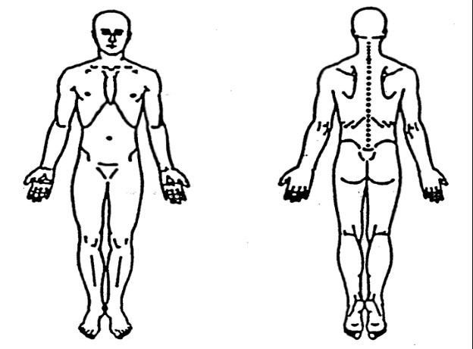
Please complete the diagram by hand after printing the entire form.
Height___________ Weight_______

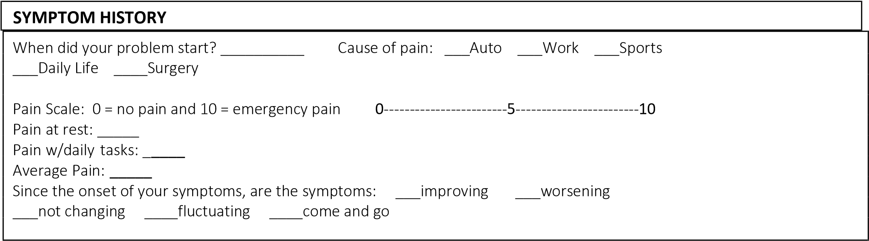
What diagnostic tests have you had? ___X-rays ___CT Scan ___Bone Scan ___MRI
___Arthrogram ___Discogram ___Other ______________________________________________
Results: ____________________________________________________________________________ Have you previously had therapy for this diagnosis? Y / N
Below is a list of words. Please check the ones that best describe your symptoms.
___lightheaded ___sharp ___hot/burning ___radiating ___stiff
___unsteady ___stabbing ___cold ___tingling ___constant
___nauseous ___shooting ___deep ___numb ___intermittent
___spells ___pinching ___dull ___heavy ___ringing in ear/fullness
___dizzy ___swollen ___ache ___pressure ___disabling

